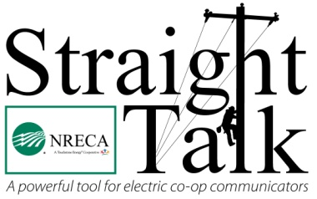
NRECA’s Straight Talk
April 2017
National Lineman Appreciation Day
Planning Guide

NEW! National Lineman Appreciation Day Resources

Found in the April 2017 issue of Straight Talk:

- Print Ad (native files are included)
- Press Release
- Social Media Cover Image (sizes for Facebook and Twitter, native files are included)
- Four Social Media Memes (native files are included)
- Sample Social Media Posts and Celebration Ideas (below)
- Quick video about a lineworker’s safety gear

*Don’t forget about past resources for Lineman Appreciation Day, available on cooperative.com.

Sample Social Media Posts (for Facebook and/or Twitter):

Suggested FB post (graphic 1): They put their life on the line for our community. Today and every day, #ThankaLineman <IMAGE>

Suggested tweet (graphic 1): They put their life on the line for our community. Today and every day, #ThankaLineman <IMAGE>

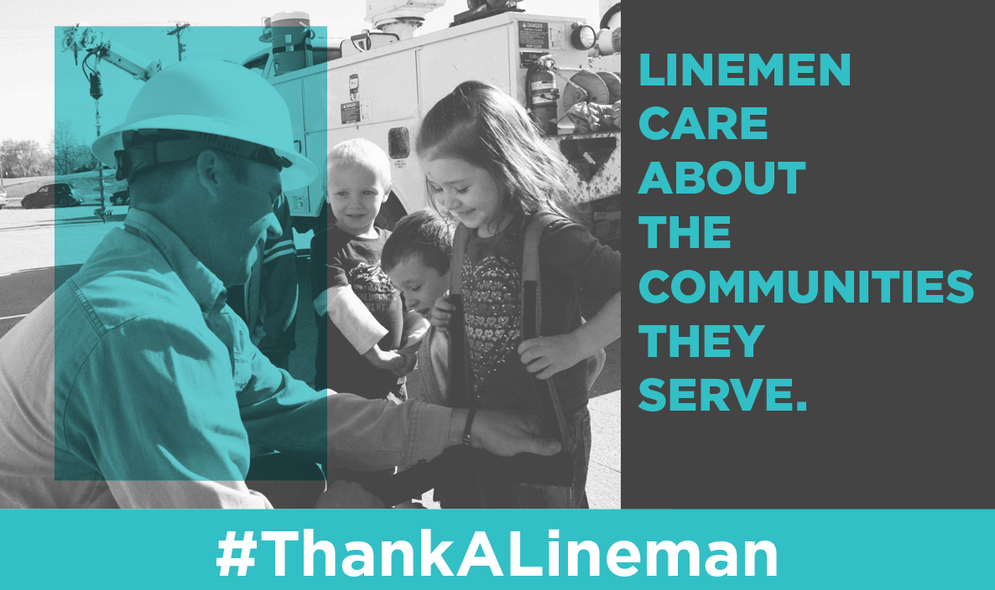

Suggested FB post (graphic 2): First responders for friends. First responders for felines. Today and every day, #ThankaLineman <IMAGE>

Suggested tweet (graphic 2): First responders for friends. First responders for felines. Today and every day, #ThankaLineman <IMAGE>

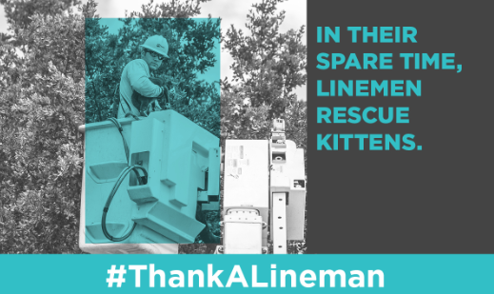
Suggeted FB (graphic 3): Bringing power to the people, wherever they may me. Today and every day, #ThankALineman <IMAGE>

Suggested tweet (graphic 3): Bringing power to the people, wherever they may me. Today and every day, #ThankALineman <IMAGE>

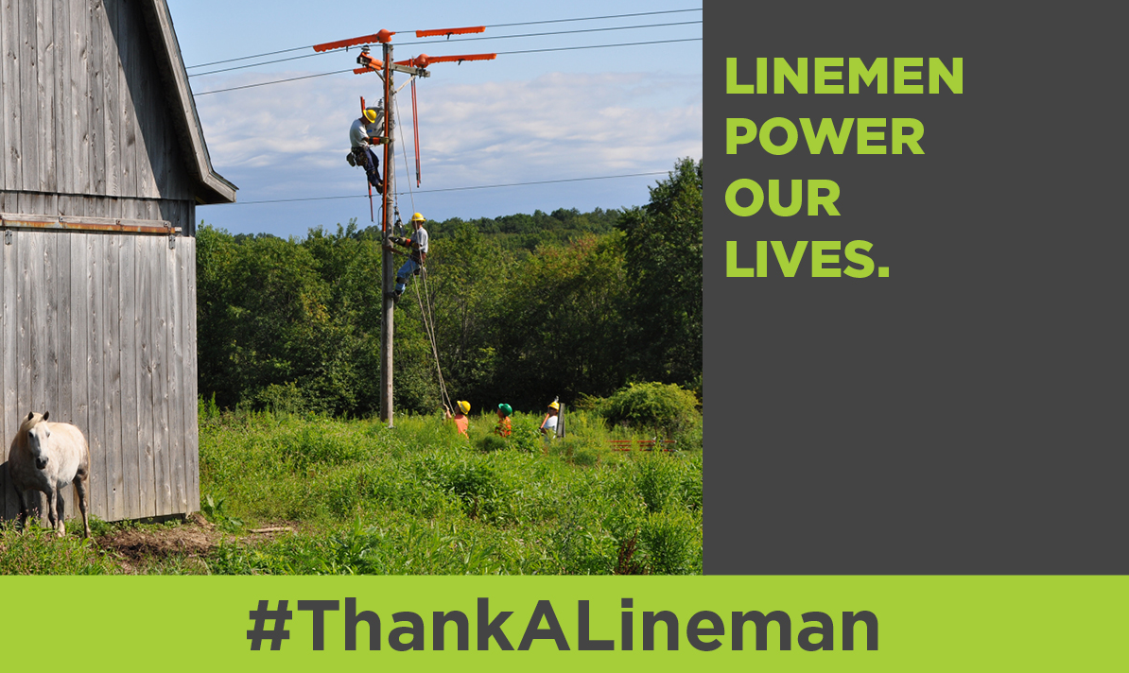

Suggeted FB (graphic 4): Celebrating the power of restorative care. Today and every day, #ThankALineman <IMAGE>

Suggested tweet (graphic 4): Celebrating the power of restorative care. Today and every day, #ThankALineman <IMAGE>

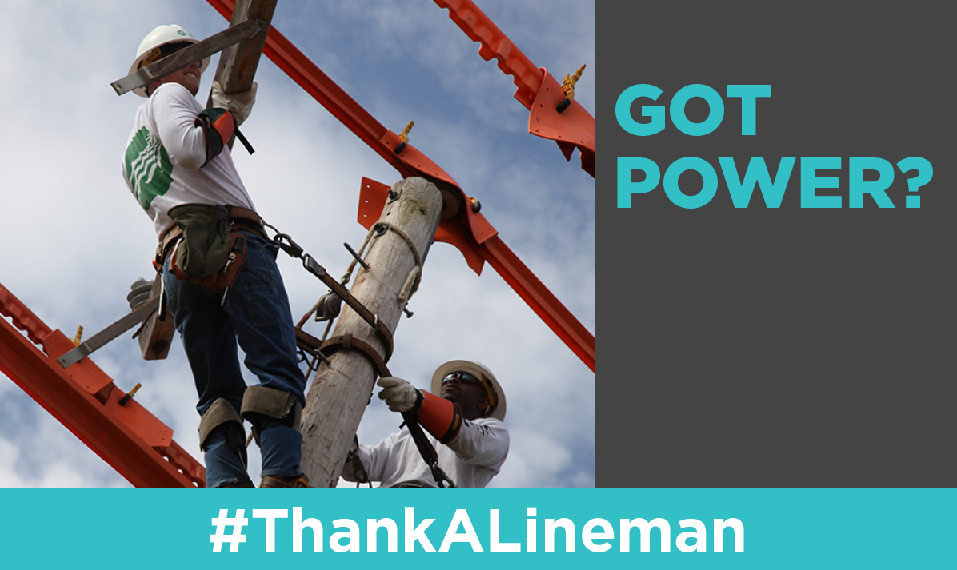

Lineman Appreciation Day: NRECA Board Resolution (2015)

"Whereas linemen leave their families and put their lives on the line every day to keep the power on; Whereas linemen work 365 days a year under dangerous conditions to build, maintain and repair the electric infrastructure; Whereas linemen are the first responders of the electric cooperative family, getting power back on and making things safe for all after storms and accidents; and Whereas there would be no electric cooperatives without the brave men and women who comprise our corps of linemen; Therefore be it resolved that NRECA recognize the Second Monday of April of each year as National Lineman Appreciation Day and make available to electric cooperatives, materials and support to recognize the contributions of these valuable men and women to America’s Electric Cooperatives."

Ideas for celebrating Lineman Appreciation Day:

Below are several ideas for celebrating Lineman Appreciation Day. Is your co-op planning something special that you don’t see on this list? Let us know and we’ll add it! Email StraightTalk@nreca.coop.

- In early April, leave blank thank you cards in the lobby for members to write words of appreciation. Display the cards for all to see on April 10. Blank thank you cards could also be sent to local schools for students to fill out.
- Use your smartphone to record a quick video of an interview with a lineman, and post it to your social media pages and website. Try to keep the video between one and two minutes for quick uploads. You could post these videos daily to generate more interest.
- If time allows, order “#ThankALineman” stickers to pass out on April 10. These could be given to co-op employees and members. You could also send the Lineman Appreciation Day press release and stickers to local media and government officials to promote the occasion.
- Consider ordering posters, banners, T-shirts, bumper stickers and/or magnets.
- Purchase items, such as utility knives, coolers, etc., for linemen. Include the date and your co-op’s logo.
- Work with local schools and plan a day for linemen to visit with students and speak about the job of an electric co-op lineman.
- If time allows, include a “Circle the Date” announcement in the next cycle of bills.
- Host a reception or dinner for your co-op’s linemen.
- On April 10, provide snacks in the lobby for members and tell them about Lineman Apreciation Day.

###

